Logo Shop | Clothing | Custom Jerseys | Corporate Gifting | Services | About | Our Store
Section 1:
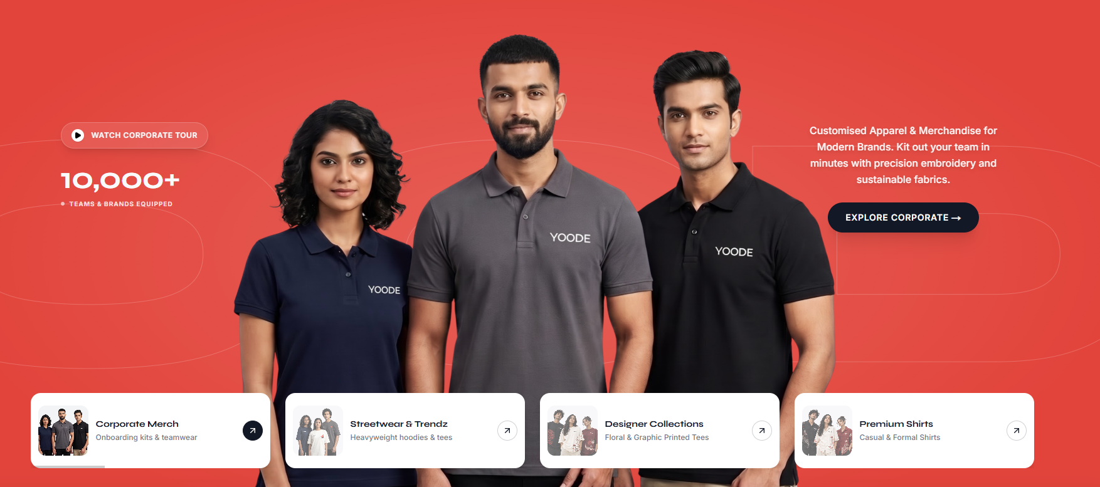
Section 2:

No Minimum Order
Choose your preferred look
50+ Colours
Choose your preferred look
Custom Printing
DTF • DTG • Embroidery • Coloreel
Pan-India Service
Order & support across India
Bulk & Business Orders
Built for teams and businesses
Section 3:
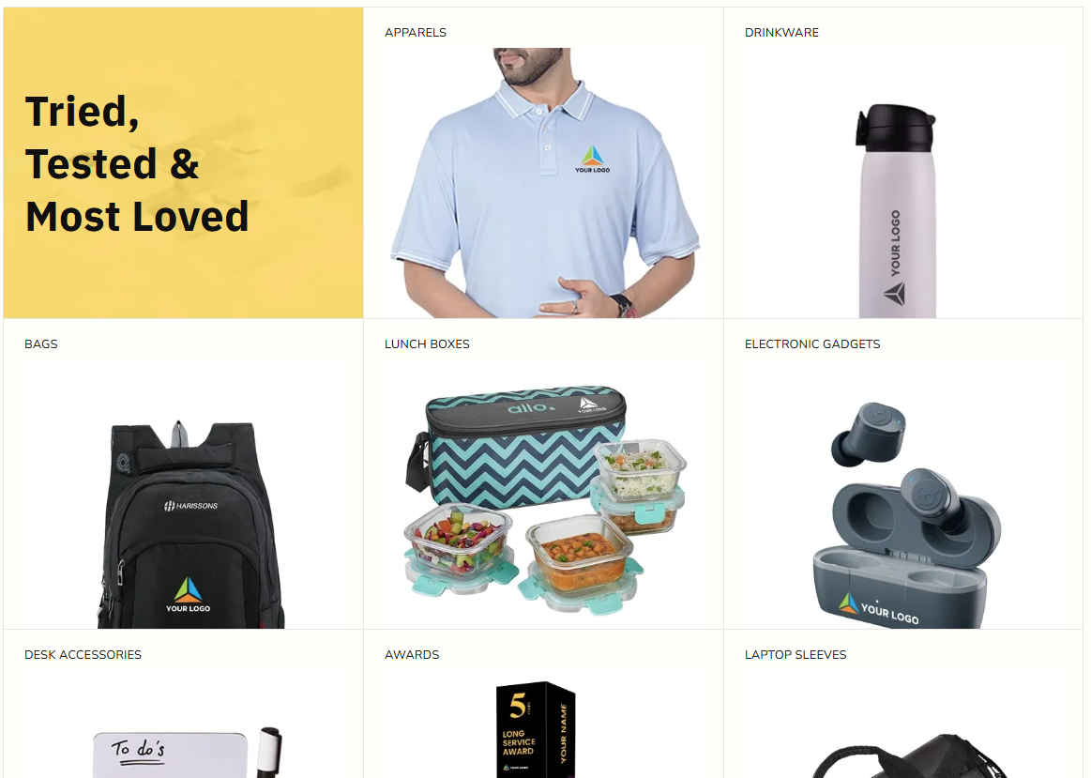
Section 4:
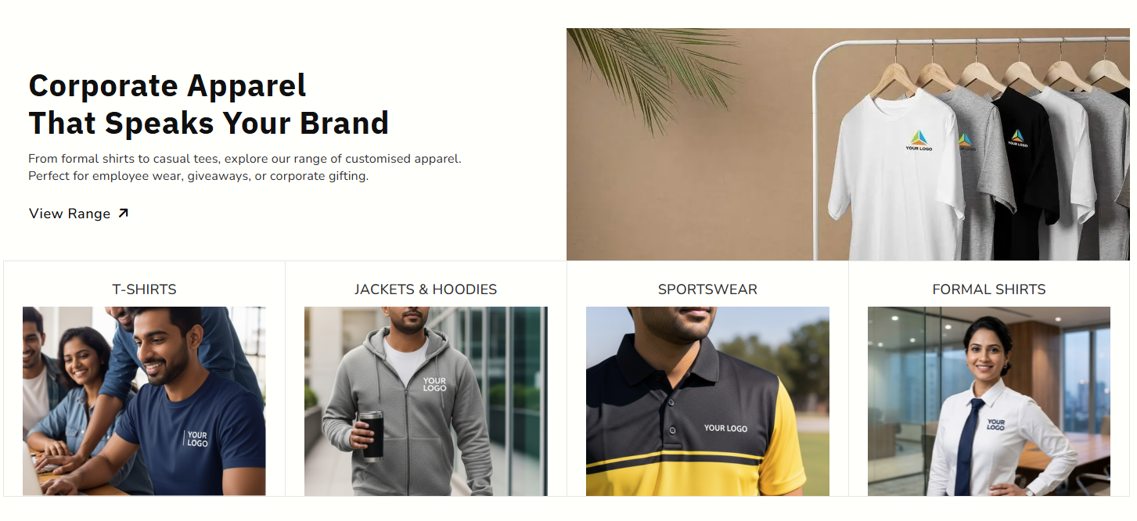

Section 5:

Find the Right Apparel for Every Need
Custom T-Shirts
Sports Jerseys
Polo T-Shirts
Hoodies & Sweatshirts
Section 6:

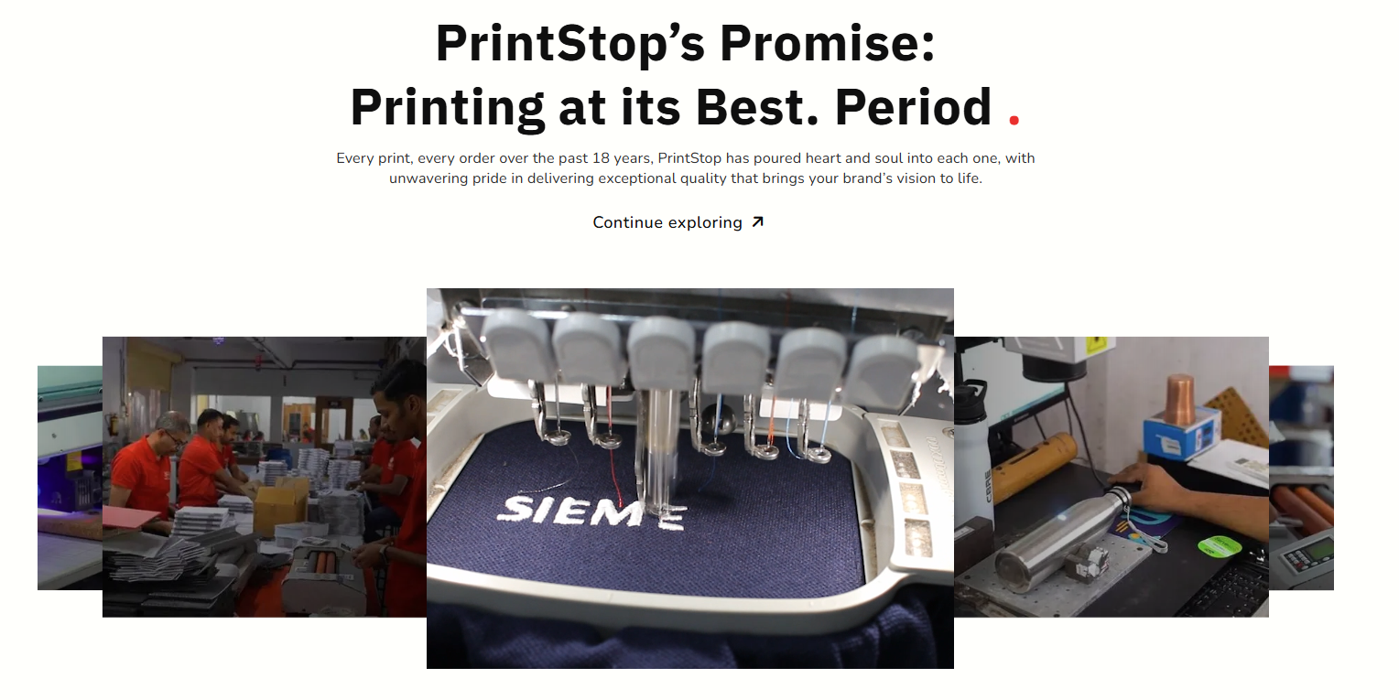
SEO benefit
These services can eventually link to dedicated landing pages:
/services/dtf-printing/
/services/dtg-printing/
/services/embroidery/
/services/coloreel/
Section 6: Why Yoode
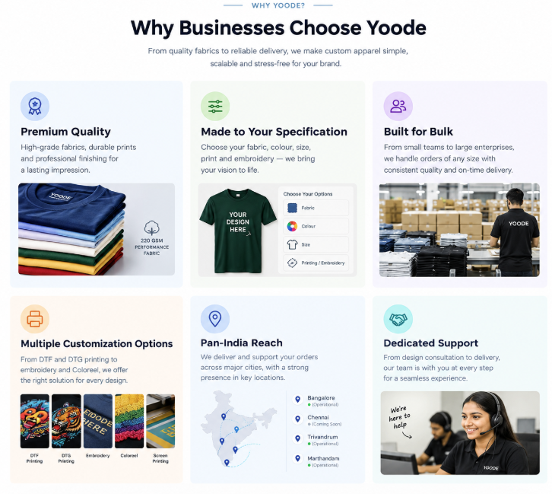

Section 7: How it Works:
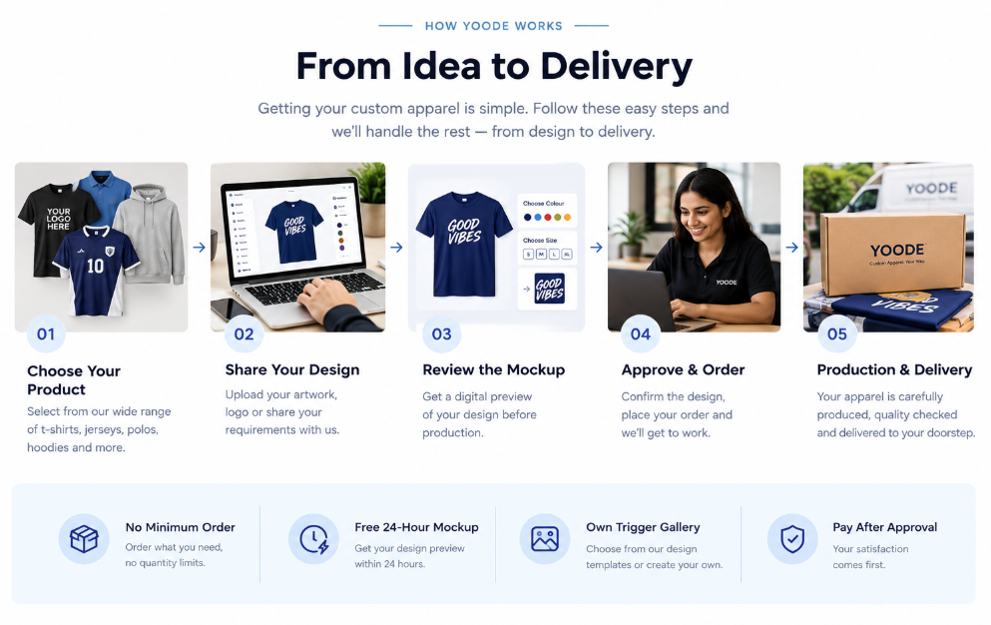

Section 8: Trusted Brands
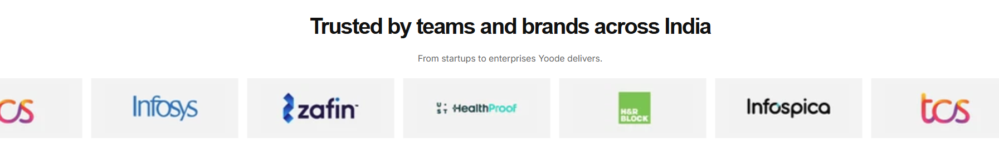
Section 9: About Yoode
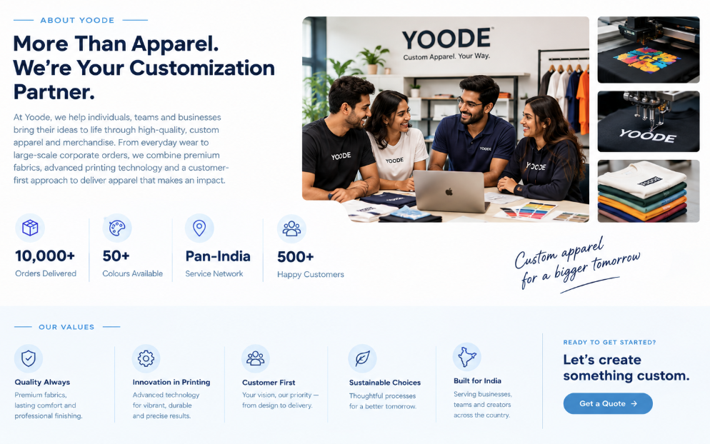
Section 10: Reviews
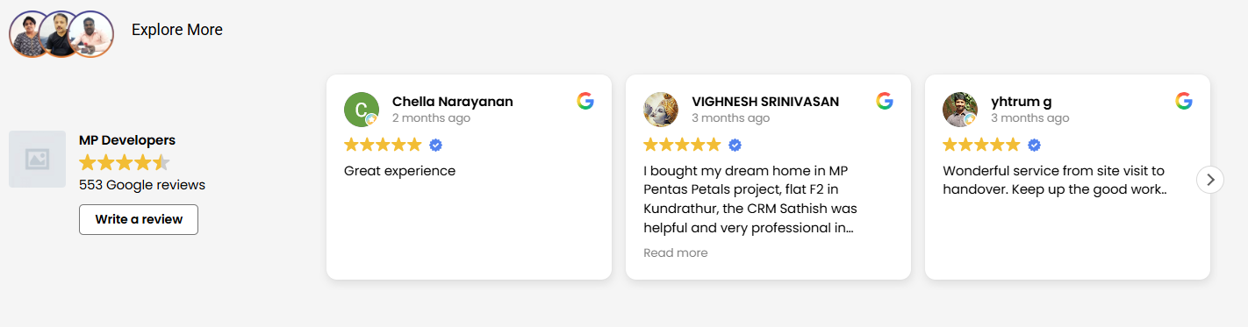
Section 11: Location
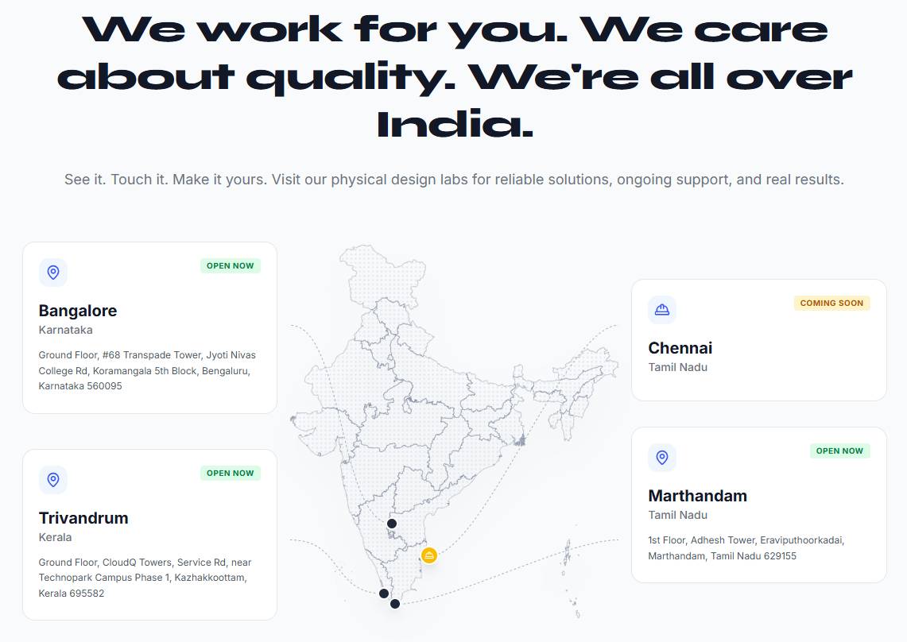
Section 12: Blogs
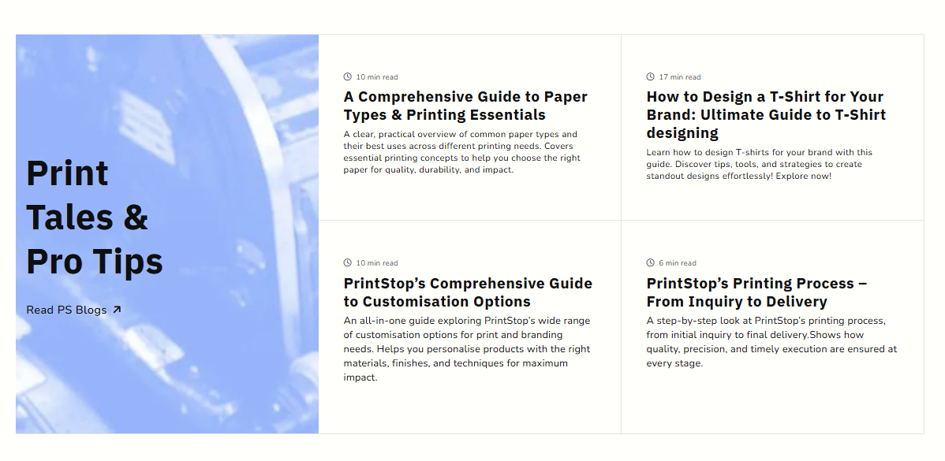
Section 13:

Section 14: Footer

